Exercise 6
Create a report which takes two date and time and calls the RFC to calculate the difference between the two dates. The difference should be in no. of days and no of hours. The input to the report is provided from a txt file and displays the output using ALV.
date.txt file:
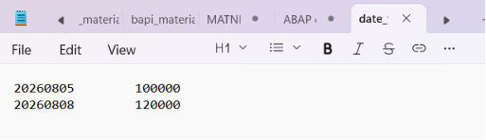
Out put:
